LearningCE Enrollment Group Administrator Member User Guide
Contents
LearningCE Enrollment Group Administrator Member User Guide 1
The Enrollment Group 2
Role 2
Accessing Your Enrollment Group 2
Adding & Managing Members 3
Enrolling & Paying for Users 7
Tracking Course Progress 8
Course Reports and Data 11
Appendices 16
Appendix 1 – Full Dashboard Report as PDF 16
Appendix 2 – “Enrolled Courses” Data Download as Excel 17
Appendix 3 – “Enrolled courses” Data Download as PNG Visualization 17
Appendix 4 – “Enrollment group enrollments” Data Download as Excel 17
Appendix 5 – “Course objects” Data Download as Excel 17

The Enrollment Group
The following will provide a general overview of the Enrollment Group, including roles, access, and adding/managing users.

Role
- As Administrator, you can:
- Add/edit roles/remove members from the Enrollment Group
- Enroll and pay (if applicable) for the courses group members
- Track course progress
- Access and utilize reports

Accessing Your Enrollment Group
- Log in to LearningCE
- Click the “My Account” tab
- Scroll down and you will see the header “Enrollment Groups”
- Click the hyperlinked enrollment group which will take you to your group
- You will now see your home page:
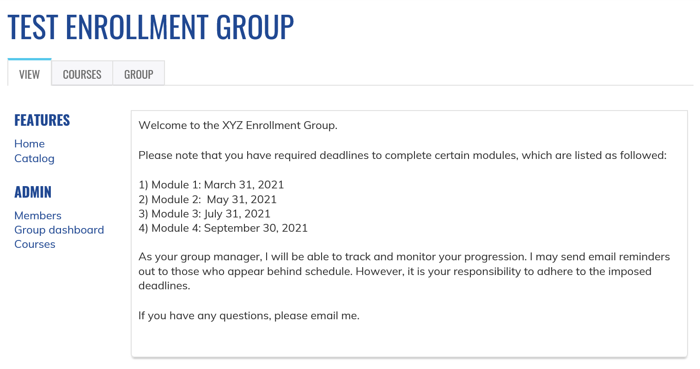

Enrollment Group Home Page Headers

Tabs at Top:
- Courses – will show the course(s) associated with your Enrollment Group. You can add or manage enrollments on this page (same as “Courses” referenced below)
- Group – you can add or manage group members on this page

Headers on Left of Page:
Under “Features”:
- Home – will take you to Enrollment Group home page
- Catalog – will show the course(s) associated with your Enrollment Group in view only

Under “Admin”:
- Members – shows who is in the enrollment group; allows administrator to add, edit, or remove members
  - Note: you will always see “SHEA Administrator” in your group and they cannot be edited or removed
2) Group dashboard – how to view and/or save data from your enrollment group
3) Courses – will show all the courses associated with your Enrollment Group. You can add or manage enrollments on this page (same as “Courses” referenced above)

Adding & Managing Members
Please note: before you can add members to the group, they must have a SHEA account
  - New account creation: Register new account
  - If the individual is unsure if they have an account with us, please visit this link and enter your email. If you do not have an account with that email, the website will tell you.
  - We highly recommend you only allow members to either be standard members (no privileges) or “Administrator member” (full admin privileges).

However, if you will have a member in the Manager role who will be enrolling users, you as Administrator must add all users into the group before the Manager can enroll them into the courses

If you will not have a member in the Manager role you may skip to “Enrolling Users into Courses” because if you enroll a user into a course associated with your group, it will also automatically add them to your enrollment group and save you time.

Adding Members to the Enrollment Group
- From your Enrollment Group homepage, click on “Members” which will bring you to the following overview page:
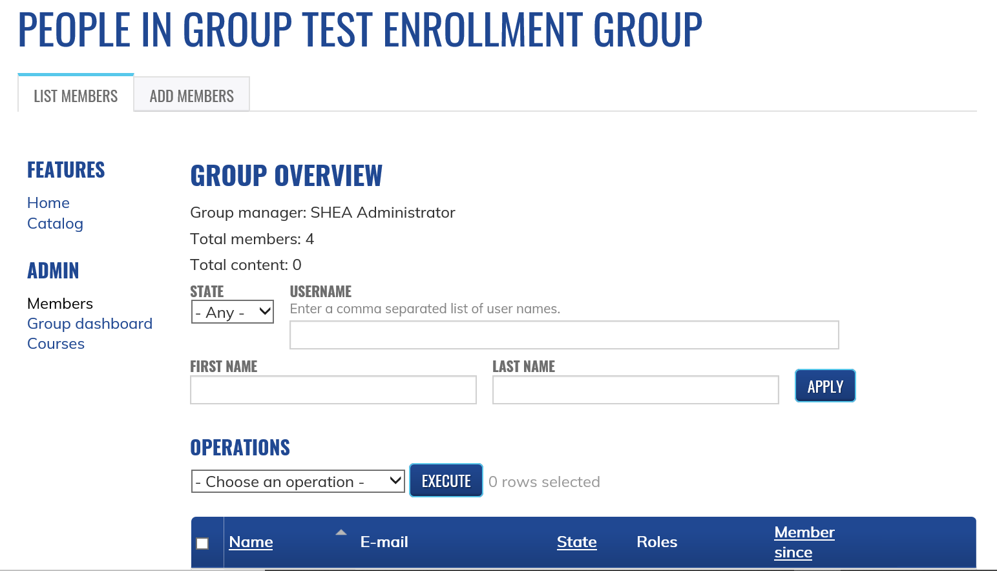

- Click on the “Add Members” tab at the top of the page. You will see the following:
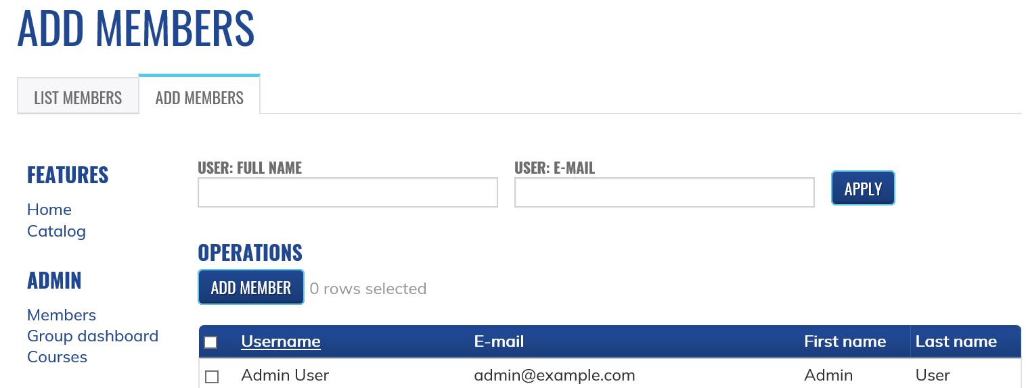

- You may search by the user’s name or their email address. Then click “Apply”
  - This includes partial name or email searches, such as “@shea-online.org”
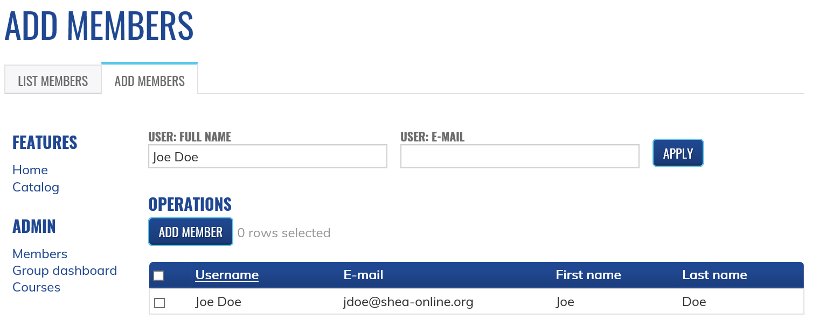

- Check the box by the user’s name (be sure to double check it is the correct person)
- You may then search for another user and add them. The system will keep track of all boxes you check. You can reset your selections at any time by clicking “reset” by the Add Member box
- When you are finished, click the “Add Member” box
- You will get a message confirming you want to add the user(s). If yes, click “Confirm”
- After processing, the system will take you back to the page in the photo listed above, so click the “List Members” tab to see who was added

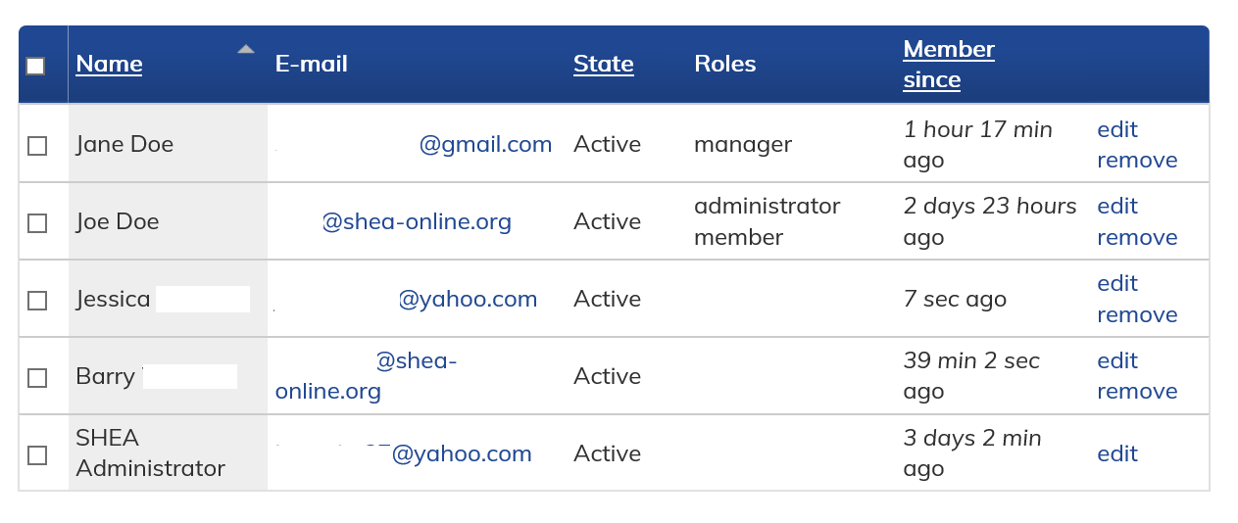
(For the purposes of this guide, we have hidden last names and portions of email addresses. You will see all of it in your enrollment group.)

Editing & Removing Members
As an Administrator, you can edit user roles or remove users from the group. You can do this individually or in batches on the “Members” page.

Individual
- Once you are on the “Members” page, you can click “Edit” or “Remove” a user
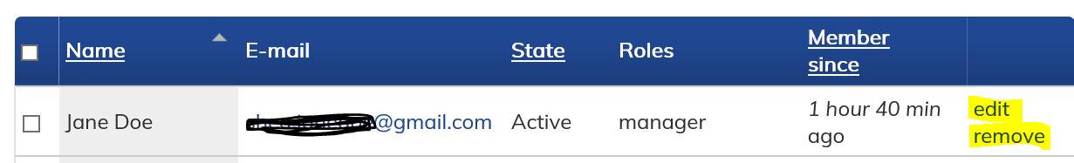
- Clicking the “edit” link will allow you to change the user’s status (Active, Pending, Blocked), assign a user to be a Manager or Administrator, or remove them from the group.
  - Active – they are an active member of the group
  - Pending – they will not be able to access the group. The group will still show in their account profile, but they will get an “Access Denied” message if they try to access it. You will have to change their status back to “Active” so they can join again
  - Blocked – they will not be able to access the group. The group will still show in their account profile, but they will get an “Access Denied” message if they try to access it. You will have to change their status back to “Active” so they can join again
    - If you have already enrolled them into a course, then they will still have access to the course
    - If you do not want the learner to even see the Enrollment Group on their account page, please see item 3 below on removing a member
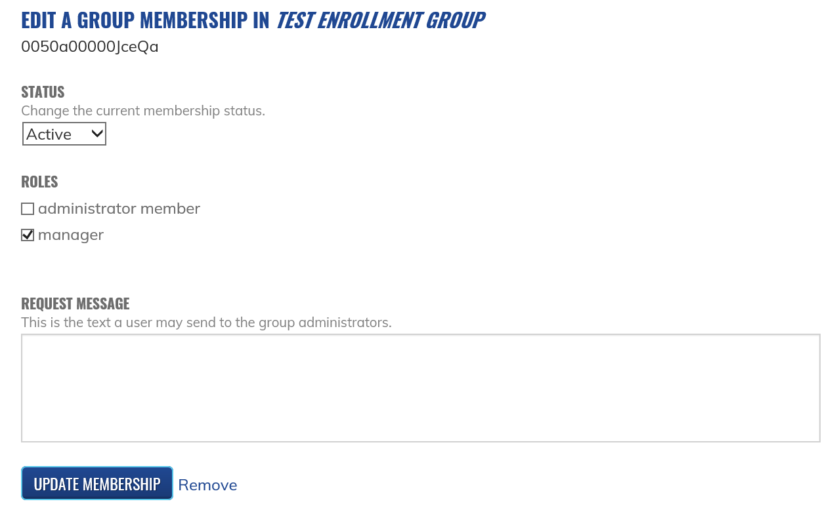
- Clicking the “remove” link will allow you to remove a user from the group. Once removed they will not be able to rejoin the group unless they are added again. You will be required to confirm removal when you click on the link.
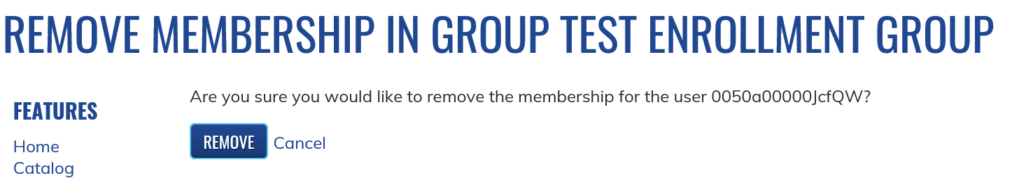

- Removing a member will NOT unenroll them from the course. That user will still be able to access and complete it.

Batch
- Once you are on the members page, you can do a batch update of membership status, user role, or group removal.
- Check the boxes next to the users you wish to update or click the check box in the blue header area to select all users
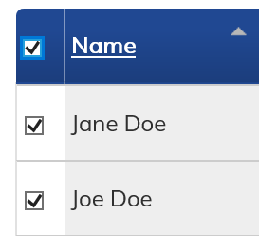
- Click on the “Choose an operation” drop down box to select the appropriate action
- Click “Execute”
  - If you choose “Modify Membership Status” you will be taken to a page that will allow you to change their status between active, pending, or blocked. Click next and then confirm your changes.
  - If you choose “Modify OG Users” then it will take you to a page that will allow you to add or remove roles. Click next and then confirm your changes.
  - If you choose “Remove From Group” then it will take you to a page to confirm if you wish to remove the members. Click confirm to remove.

Enrolling & Paying for Users
- Click on the “Courses” link to see all courses associated with your group
- By each course, you will see “Add | Manage”. Click on the “Add” link
- Type in their name and/or email address and click “Apply”
- Select the user you wish to enroll by using the checkbox by their name
  - You may add multiple users at one time. The system will keep track of all users that you select by providing the message “x rows selected.” You can also click the “reset” link to start over.
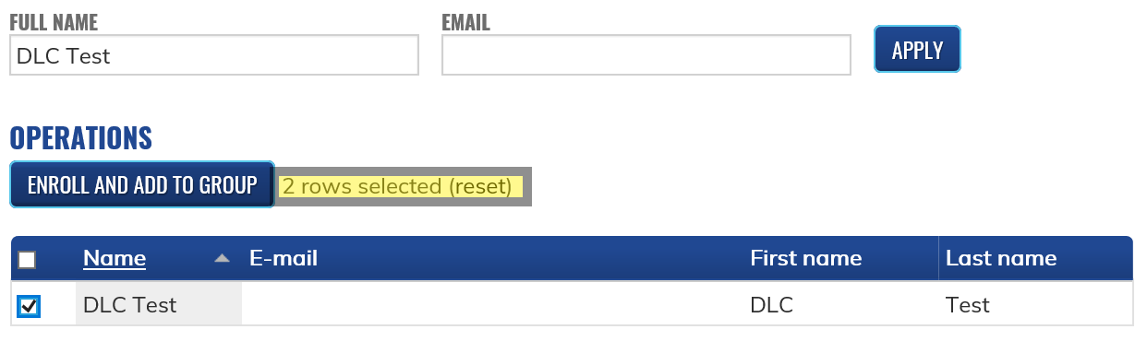
- Click the “Enroll and Add To Group” button
- On the next page, after you review your selections, click “Confirm” to enroll the user to the course and add them to your enrollment group. Click “Cancel” if you have made an error
- Click the “Manage” button at the top to view enrolled users
- If a course is free, then you are finished, and users can begin their courses at any time. They will receive an email confirmation that they have been enrolled into the course. If not, please see the below section on “Paying for Courses”

Paying for Courses
(Please note: you may only pay for group enrollments using a credit card)
If a course has a fee and you are doing a group enrollment, please follow all the steps above. Once you get to step 7:
- Look at the shopping cart icon in the upper right corner of your screen. This is where all unpaid courses will live
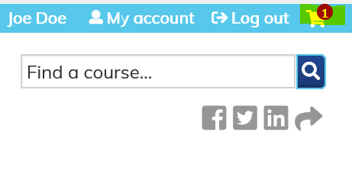
- When you have finished enrolling all users in all the desired courses, you will click on the shopping cart. It will include all users enrolled in the course
- If everything looks correct, click on the “Checkout” button
- Enter your billing information and click “Review Order”
- Confirm everything is correct on the screen and click “Pay”
- You will see a pop-up in which to securely enter credit card information. Click “Pay” when you are done
- Once payment is confirmed, each user you enrolled will get an email confirming they have been enrolled in the course
  - You can find your order confirmation by clicking “My Account” then the “Orders” tab
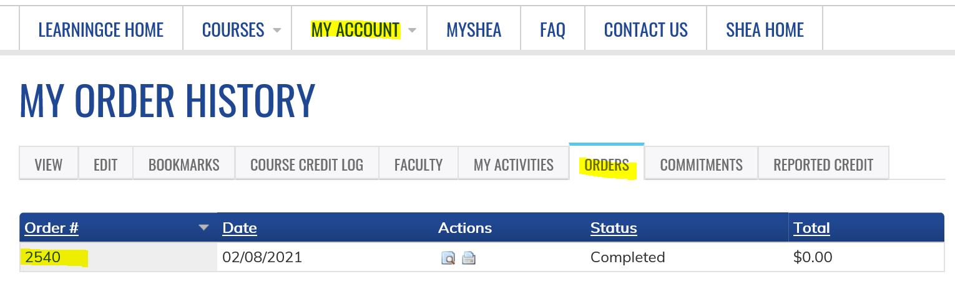

Tracking Course Progress
Note: You may also track specific course progress. Please see Course Objects: Tracking Course Completion report below
- Click on “Courses” under the “Admin” header
- Click on “Manage” next to the module you wish to view
- If you click “Manage” next to the Primer in Healthcare Epidemiology, Infection Prevention, and Antimicrobial Stewardship, you will not get as detailed of information
- You will be able to look at the dates they started and completed the module and status
Example of what you will see if you click manage next to the main Primer course:
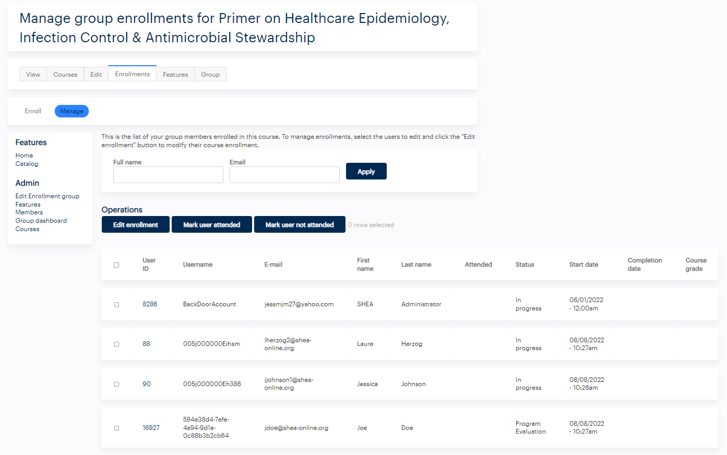
Example of what you will see if you click manage next to each individual module:
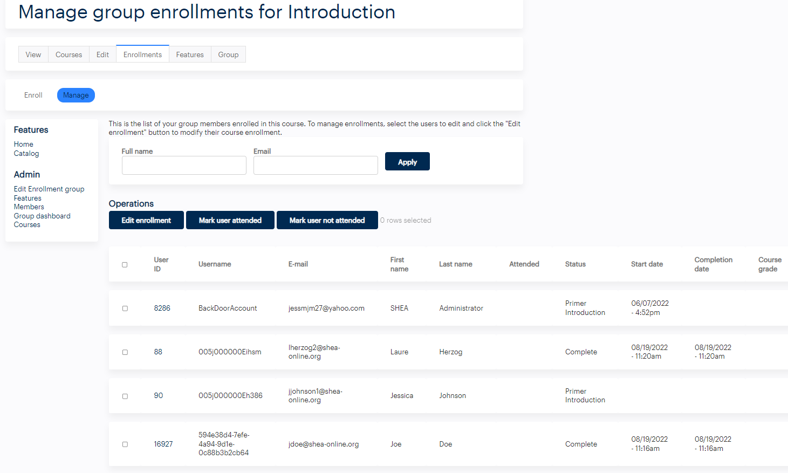

- This data will tell you where the learner is in this module. For example, Laure and Joe Doe have both completed the introduction module while SHEA Administrator and Jessica are still in progress.
- You may download this data by clicking the red “CSV” box located below the list of learners and their statuses.

Make changes to enrollments:
The “Edit Enrollment” button allows you to adjust the following:
- Course start date and time (when the user started the course)
- Course access date and time (when the user will no longer have access to the course)
- Completion status
- Course completion end date and time
- Individual module completion status
- Ignore the “Mark User Attended” and “Mark User Not Attended” as the courses you will utilize will all be eLearning & do not require attendance
Making Changes to Enrollments:
- Click “Courses” under the “Admin” header
- Find the course you want to edit and click the “Manage” link
- Check the box by the user(s) you wish to edit and then click “Edit Enrollment”
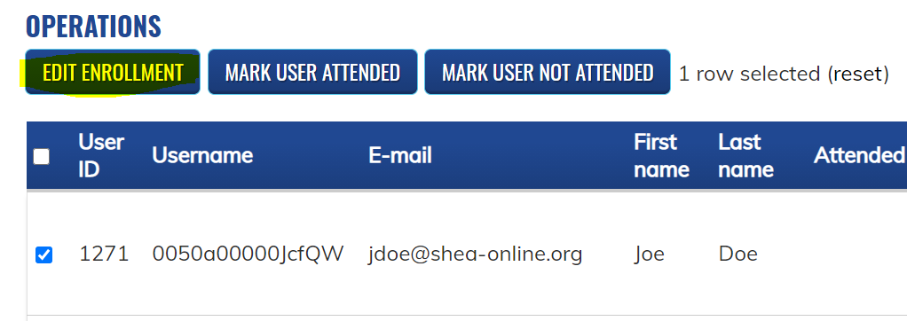
- Make your changes and then click “Next”
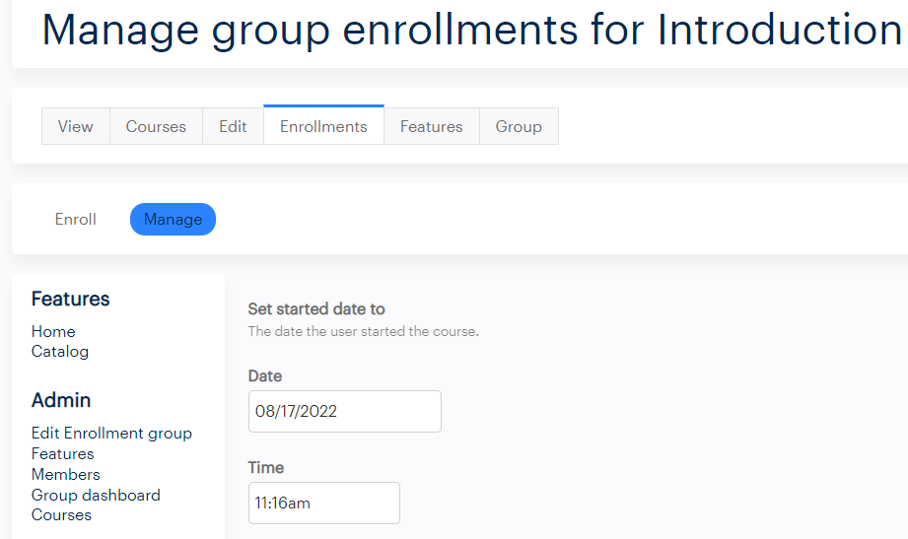
- Click “Confirm” on the following page and allow system to process
- See the changes after completion
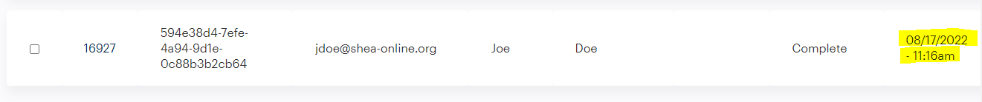

Course Reports and Data

Group Dashboard
The Group Dashboard allows you to see numbers from an “at-a-glance” perspective, but also allows you to create both simple and customized reports depending on your group’s needs.

Dashboard Home
Accessing Dashboard:
- From your enrollment group home page, click the “Group dashboard” link
  - This can sometimes take several minutes to load depending on number of users in your group, number of courses associated with your group, internet speed, and more. Please do not hit the refresh button as that will slow loading your dashboard
- After the dashboard loads, you will see this as a landing page (the photo below only shows a partial view due to size constraints):
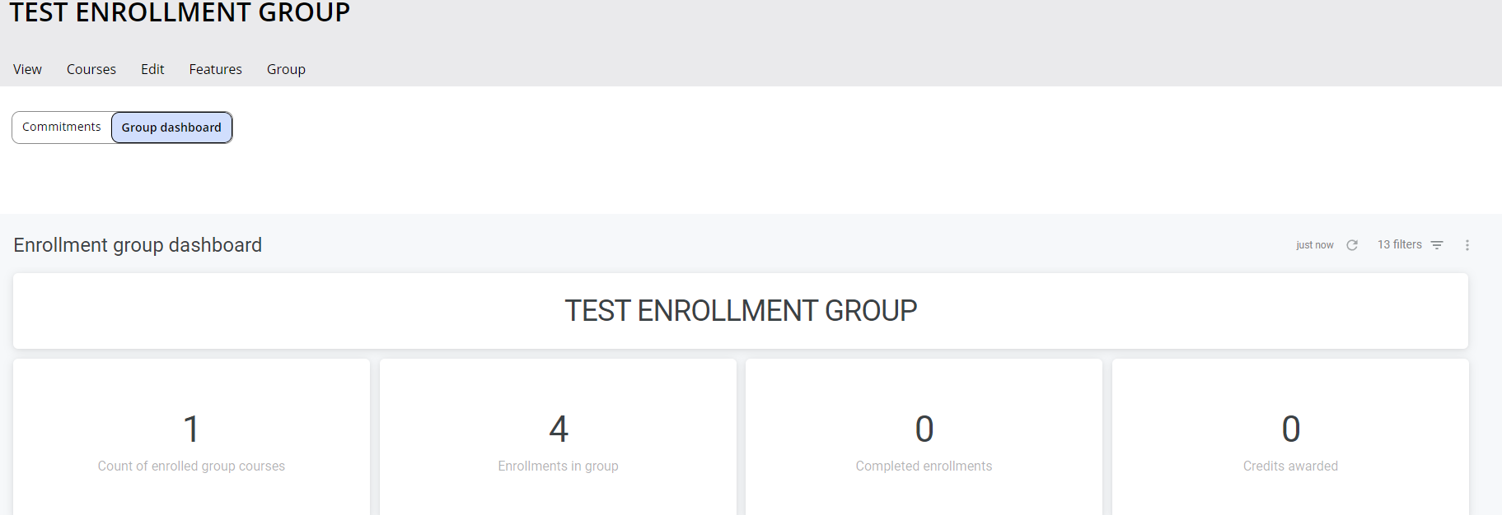

- You may exit the dashboard by clicking the following at the top (these will not open new windows and take you away from the dashboard page; see screen shot below):
  - “View” – will take you to Enrollment Group homepage
  - “Courses” – will take you to the course page tied to your Enrollment Group
  - “Group” – will take you to the “Add/Manage” members page
  - “Commitments” – ignore. It is not applicable
  - “Group dashboard” – will reload the dashboard again

Dashboard Overview:
- The dashboard homepage will provide the data in an “at-a-glance” perspective. At the top of the page, you will see overview information such as how many users are enrolled in your group, how many users have completed their enrollments, and credits awarded (as seen in the image above).

- As you continue to scroll down, the dashboard will provide even more specific information, such as the courses that are associated with your group, users enrolled in your group, and credit records.

See below for an example of what the Enrollment Group Dashboard may look like:

You may also filter this data by using the parameter selection tool at the top of the page (see example below):
- Click the small arrow next to “Filters” to expand and set parameters. However, do not change the Group ID as that is specific to your enrollment group. Click the blue “Run” button when you are ready to run a new dashboard report. Again, do not hit the refresh button while this is processing.
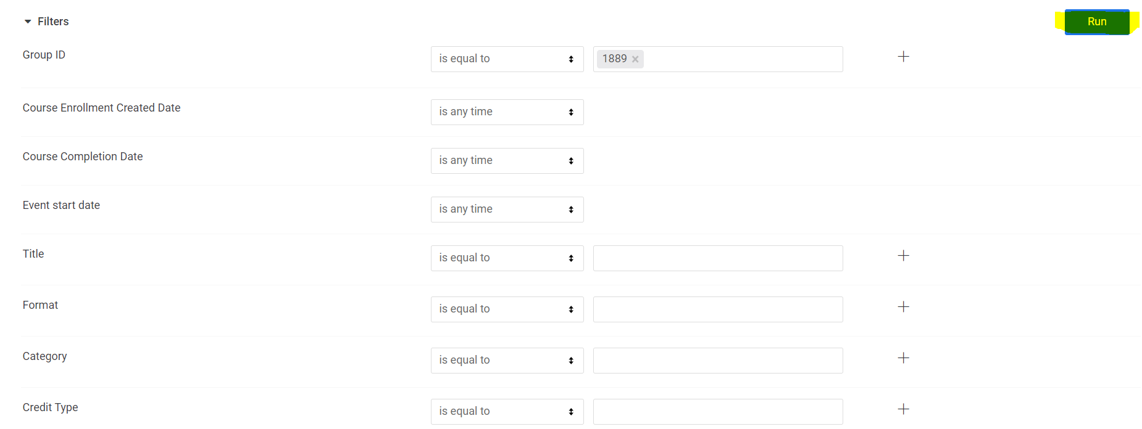

- You can also download the dashboard as a PDF, as CSVs, send, or schedule.
  - Download as PDF – will create an exact replica of the current dashboard home screen
  - Download as CSVs – will download each dashboard data set as a CSV and will download as a zip file
  - Send – send the dashboard as a PDF, Visualization, or CSV Zip file via email, Webhook, Amazon S3, or SFTP
    - You can use the filters within the feature to customize what data is sent
  - Schedule – allows you to schedule when the dashboard data is sent via email, Webhook, Amazon S3, or SFTP
    - You can schedule on a repeating interval or on a data group update
    - You can use the filters within the feature to customize what data is sent

Course Objects: Tracking Course Completion
  - In the Enrollment group dashboard, you have a header, “Course Objects”. This will show every module that your members have enrolled in, every course object in that module), and completion status for each. This is the most detailed course progress report available for Administrators.
  - You will want to utilize columns 1-7 (First name through Course object title) for collecting information.
  - You may schedule this report to be sent to you or download it at any time. Please see Individual Report Features in Dashboard below to learn how.

Individual Report Features in Dashboard
If you hover over each data set presented in the dashboard, a bell and three vertical dots will appear.
- Bell - set alarms that will email you a notification if the parameter you set is met. For example, if you are anticipating 15 enrollments in a group, hover over “Enrollments in group”, click the bell, and set the condition so that you (or other individuals) are notified via email when the enrollment number is hit.

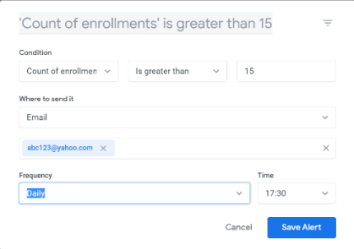
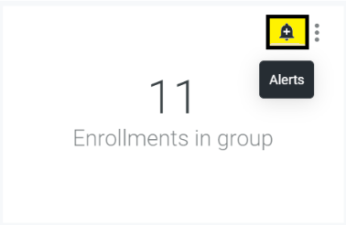
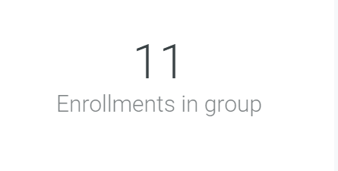
- Three vertical dots – download the individual data set in many different formats.
        - Note: Be sure to also change the “Limit” from “Results in Table” to “All Results” to capture all of your learners in the report.

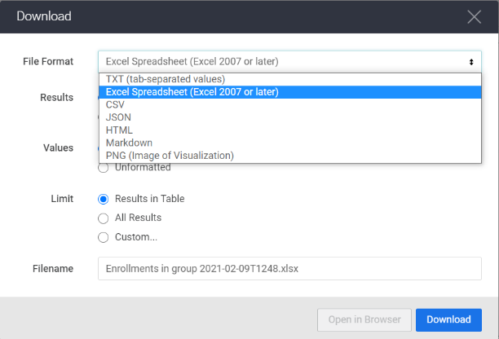
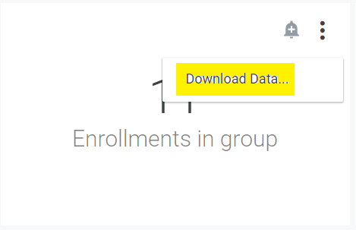

    - Sample downloaded reports can be seen in the Appendices section

Individual Reports in Enrollment Group
You can also download simple reports directly from your Enrollment Group. These two reports and how to generate them, are described below.

Member Report
Because the Administrator as access to the “Members” dashboard, they can generate an Excel CSV file that includes Enrollment Group Member information. This will have information such as name, email address, and other demographic information. To access this report:
- From the enrollment group home page, click “Members”
- At the bottom of the page, click on the red “CSV” button
- The system will show you the progress of the report generation
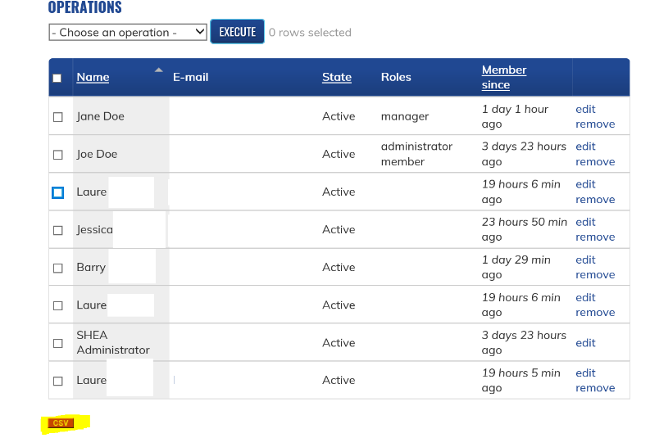
- Once complete, the system will allow you to view/download yourself or it will automatically download for you
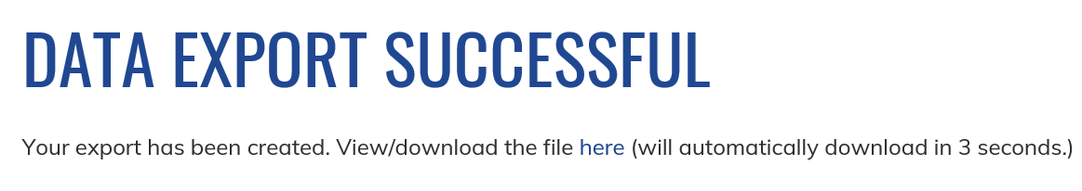

Course Enrollment Report
This report’s only difference from the Member Report is that it also includes when a user started a course, course status, and when a user completed a course. This report is not available in the Dashboard, so to track individual course progress, you will need to utilize this report. To access the report:
- From the enrollment group home page, click “Courses”
- Click “Manage” next to the desired course
- At the bottom of the page, click on the red “CSV” button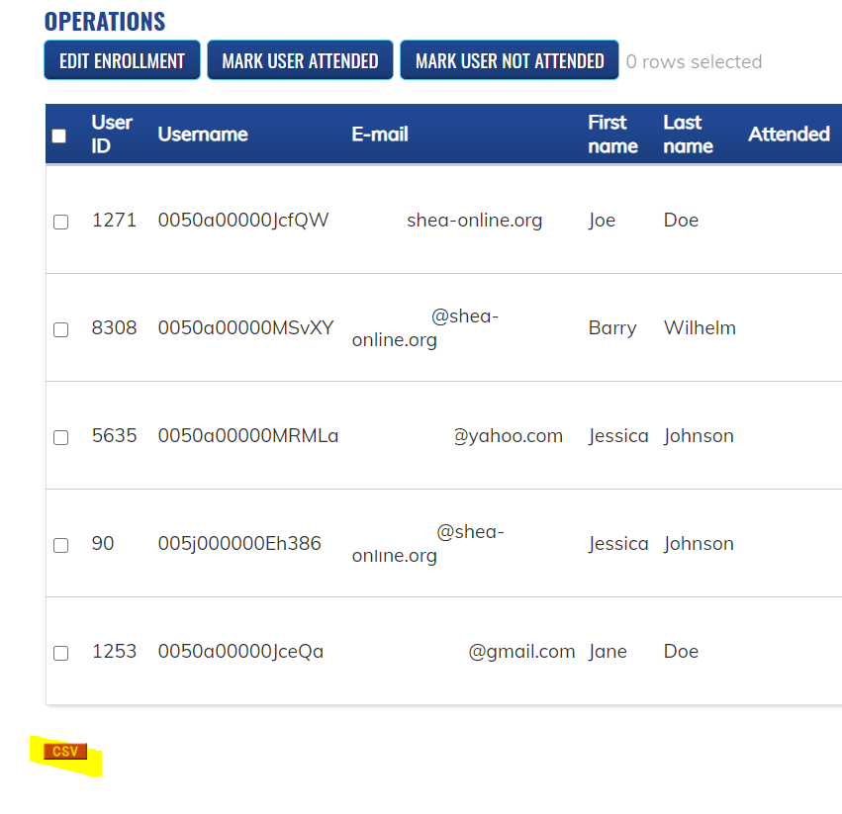
- The system will show you the progress of the report generation
- Once complete, the system will allow you to view/download yourself or it will automatically download for you
- You can then edit the report in Excel to your satisfaction
- Remember this report will not show every module that has been completed and you will have to do that through the steps in Tracking Course Progress for individuals or Course Objects: Tracking Course Completion for group data.

Appendices

Appendix 1 – Full Dashboard Report as PDF
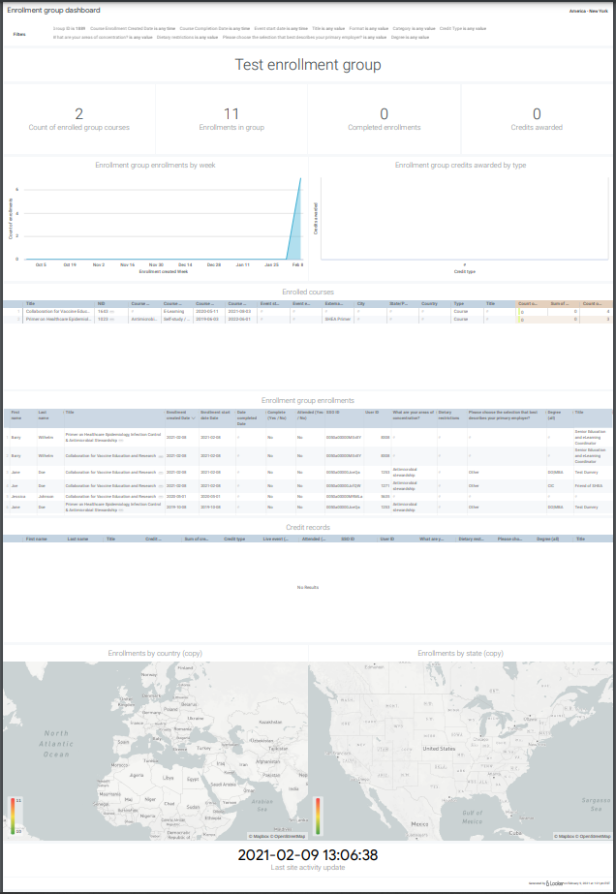

Appendix 2 – “Enrolled Courses” Data Download as Excel

Appendix 3 – “Enrolled courses” Data Download as PNG Visualization

Appendix 4 – “Enrollment group enrollments” Data Download as Excel
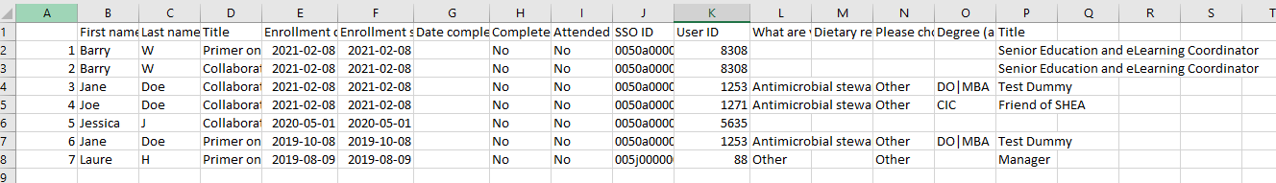

Appendix 5 – “Course objects” Data Download as Excel
