SHEA Enrollment Group Process

- Before request an Enrollment Group, the organizational contact who is running the enrollment group (Administrator) must have an account with SHEA.
  - New Account Registration
  - Login page for existing members

- The Administrator will complete the Enrollment Group Request Form with group enrollment information requirements. This information will include:

  - Individual who will serve as the Administrator
- SHEA will only setup the Administrator role. Administrator can assign a manager role, if needed. Please see below about Manager role.
- The Administrator will be the contact to SHEA as it pertains to the Enrollment Group setup and for ongoing technical support.
- Administrator and Manager Roles in the Learning Management System:
  - Administrator:
    - Can add/edit roles of/remove members of the Enrollment Group
    - Can add course enrollments using name or email address
    - Can manage course enrollments
    - Can access group dashboard for reports and download individual reports from enrollment group directly (process covered in Administrator guide)
  - Manager:
    - Can add course enrollments using only email addresses
      - Enrolling a user into a course will automatically add them to the Enrollment Group
    - Can manage course enrollments
    - Can access group dashboard for reports
  - Differences:
    - Administrator is the only person who can access the “Members” from the Enrollment Group home page
    - Administrator can add users to the enrollment group and associated course by name
      - This Administrator privilege allows them to see all users of LearningCE when adding users to the enrollment group
      - They should not abuse this privilege and only use to add appropriate users to your group
    - Manager can only enroll users into a course using their email address
      - IMPORTANT: If the Manager will be the user enrolling users into the course, then the Administrator must add all users to the enrollment group first
  - Name of Enrollment Group
- This should be unique and directly pertain to the organization or members who will be in the group (e.g. XYZ Hospital, AAA Residents, etc.)

  - Description of the enrollment group that will appear on the group enrollment home page
- At this time, the learning management system SHEA uses only allows this to be created and edited by the SHEA Site Administrator and not the Enrollment Group Administrator. For edits after submitting the initial design, please contact SHEA at LearningCE@shea-online.org. See example below:
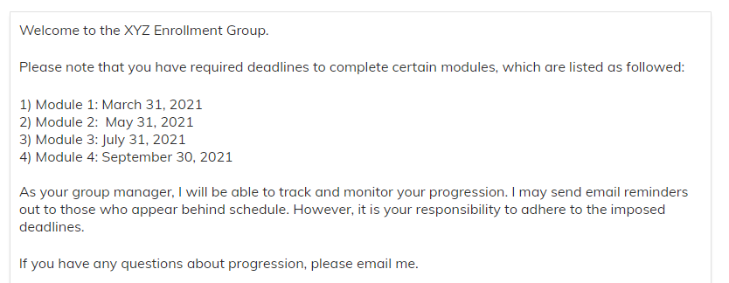

Enrollment Group Setup

- SHEA will create the Enrollment Group based on the information collected above, including Enrollment Group name and description, and adding the Administrator
- SHEA will reach out to the Enrollment Group Administrator if there are any questions or concerns pertaining to Enrollment Group setup
- Once the Enrollment Group is setup, within 5 business days of Enrollment Group request, SHEA will provide the Administrator directions on how to access the Enrollment Group for review and approval
- If changes are needed, the Enrollment Group Administrator will notify SHEA within 5 business days, SHEA will make them within 3 business days, and then send back to Administrator for approval
- After final approval, SHEA will provide full control of the Enrollment Group to the Administrator and will serve in a technical support role moving forward

Ongoing Support After Enrollment Group Setup

- SHEA will provide the Administrator, Manager, and Learner Guides
- If requested, and time is available, SHEA will provide a demonstration to the Administrator of the Enrollment Group. This will cover an overview of the Enrollment Group and its functionalities, and the demonstration will take place on a Zoom video call based on mutual availability
- SHEA will work to develop on-demand video demonstrations on how to utilize the Enrollment Group, including adding members to the group, enrolling members into courses, and accessing data and reporting
- SHEA will serve as the technical support for the Enrollment Group. The Administrator should contact SHEA at LearningCE@shea-online.org

